DeHUB KENYA HACK

Hacking is creative problem solving. (It does not have to be about technology. A hackathon is any event of any duration (Usually 48 hours) where people come together to solve problems.

WHY WE HOLD HACKATHON

* Strengthen the community that the hackathon is for.
* Be welcoming to newcomers to the community.
* Provide an opportunity for participants to learn something new.
* Provide a space and a time for participants to make headway on problems they are interested in.

REGISTRATION AND PUBLICITY

The event tickets were made available for three weeks before the event at <http://dehubhackday.eu5.org> where we got ninety nine (99) applicants. The event was mainly publicized on social media and invitation sent through ISP (Intel student partners) and MSP (Microsoft student partner) to all the universities.

JKUAT, KU, Technical university of Mombasa, Moi University, Masinde Muliro university, Nairobi University and Egerton university all said that their students were on attachment and it would be hard to send a team for the event.

Only two universities we able to come;

* Multi Media university (2 Members)
* Kisii University (1 Member)

The main reason for other universities not making it to the event was because most university students are on attachment during this period.

The event had sixty (60) participants.

* Dedan Kimathi University of Technology – (57)
* Multi Media university (2 Members)
* Kisii University (1 Member)

HACKING

We opened the hacking track at 18:00 hrs with the registration of participants entering the event, supper was served then the pitch session followed.

Hacking begins with project introductions. Participants that bring projects to the event have an opportunity to briefly (1 minute max) explain what they are working on at the very start of the event so that other participants can join that project. Cultivating good projects

Not every project pitched was a good project so we looked at projects with the following qualities.

**Clearly articulated.** Projects should have a clear question or problem they are trying to solve *plus* a reasonably specific proposed solution.

**Attainable.** Most projects will accomplish about 25% of what they think they can accomplish in the limited time they have. Manage each project’s goals so participants are able to feel accomplished at the end of the session, not interrupted.

**Easy to onboard newcomers.** Projects should have ready-to-go tasks for newcomers with a variety of skills and at a variety of skill levels.

TRAINING

A successful hackathon might be just hacking, just training, or both hacking and training.

Because we had a significant number of newcomers, we had great training workshops to give them something to do that they will be more comfortable with than diving into hacking. We mainly held the workshops to introduce participants to the subject of the hackathon and to various technical skills useful for the hackathon.

The training workshops were offered by Africa’sTalking team, they gave the developers deep dives on Mpesa API, USSD, Voice and SMS short codes. The training was very successful and this was measured by the duration the developers took to complete the projects they were working on.

The training also gave us confidence of having a big number of competent developers at the HUB. Newcomers to the hackathon also found it easy to adapt to the environment after the training and deep dives.

**PROJECTS**

We had nine projects presented and worked on at the hackathon.

|  |  |  |  |
| --- | --- | --- | --- |
| **Name** | **Reg No** | **Project Name** | **Description** |
| Peterson Muriga  Faith Ng’ethich  Justus Too  Ted Mureithi  Sabina Moraa |  | E-BLOOD | E-BLOOD is an innovative web application that enables you to connect instantly to the growing network of blood donors using location based services, connect real time to the right people. Instead of patients dying due to delays in blood delivery services, E-BLOOD will provide you with the list of those donors who will help you. It uses **SPATIAL DECISION SUPPORT SYSTEM (SDSS),** to analyze correct, measure and interpret data in real world. |
| .NJERU CYRUS  NIXON TONUI | C026-00566/2013  C026011020/2015 | Helb-Quick Payapp | **Helb-Quick Pay** app is a USSD and SMS based app that the students can use to repay their loans anywhere, anytime, any amount. The App Integrates the most widely used and trusted mobile payment platform: (**M-PESA**). With the use of M-pesa API the app allows the students to easily repay their loans using their M-pesa accounts. The app helps the user to repay their Helb loan after duration of one day, a week or a month. The app also enables the users to check their loan status and track their repayment details. |
| Brian Ontumbi  Patrick Mwangi  Samuel Otieno  Nixon Tergech  Stanley Mbote |  | E- emergency | E-emergency is a project used to solve various issues in the society. By dialing *384*1900,one can report various issues, e.g. rape case, student misconduct, accident reporting, robbery and other social cases. |
| Duncan Akello  Victor Turuthi  Kelvin Mwaniki | E020-0636/2013  C025-0946/2015 | SMS web crawler | This is a service which accepts people's requests to have all digital news platforms and sources of counties' daily news converged to their reach as soon as they are found. It incorporates a lot of media sources, from rss feeds, blogs, online newspapers, social media platforms and other sources of information and sorts them according to popularity. The service accepts inputs forms by the user from an sms. |
| Humphrey mugabi  Robert Kariuki  Brian Ndirangu  Kiprono Gideon  Duncan Gitonga  Ian Juma |  | Smart Text. | This is a sms short text app that uses the Houndify API to return to the user responses according to the query that the user makes. Houndify is integrated with modules such as the Wikipedia, Google maps API and other modules so that it can return responses to the user. It also uses the Africastalking API to integrate the app with short code messaging. For instance; sending a short message with the question “What is Google”, returns the answer to the user’s mobile phone with the answers from Wikipedia. |
| Mwai S. Muchiri  Henry Macharia  David Macharia  Peter Kirumba  Arthur Otieno | E022-010727/2013 | Auto home Afrika | Auto home Afrika is a project to easily enable the owner of the house to easily control and monitor the house system even when you are away. The project intends to have the automated light control, video surveillance accessibility, garage control, stereo system from an USSD from your phone. |
| Dennis Waweru  Dennis Njoroge  Erick Warui  Emmanuel Muema Fabisch Kamau  Kimeli Peter | C026 011027/2015  C025-011326/2013  C025-011245/2013  C026-011519/2015  C026-011037/2015  C026-011025/2015 | Lost N Found | This project is basically a system that aims at helping people locate their valuables, take a case of a mobile handset picked by some anonymous person, not everyone is faithful to hand it over to the relevant authority and again such devices are made in large numbers and are almost identical. For this reason we narrowed down to the very specific items that are unique to an individual such as National Identity Cards, Automated Teller Machine Cards, Birth Certificates, Land Ownership Documents and last but not least Organization Related Documents such as Gate Passes and Employee Cards. |
| JOSEPH KAMAU  ANTHONY MWANGI  PETER KAORA  FREDRICK MAINA  TIMOTHY KIMARI  DENZEL | C026-1557/2011  C026-010997/2015  C025-01-1636/2015  C026-01-0998/2015 | NTSA | NTSAlert™ is a smartphone app easily usable on android phones. NTSAlert™ app will help you as the user to travel safely by monitoring the speed of the P.S.V you have boarded and inform the authority when driver violates speed limits.  This application is essential in the transport network to reduce the No. of accidents and Deaths occurring. |
| Brian Kiboi  Simon Kamau  Gideon Mugo  James Ndodana  Nahashon Osinde | E022-01-0760/2013  E022-01-0737/2013  E022-01-1305/2013  E022-01-0758/2013 | Mobile Kuku | The *mobile-kuku* project is aimed at enabling farmers to rear poultry in the most efficient and profitable manner. This project provides a clear guide to aspiring individuals and farmers on rearing of poultry from the incubation stage to marketing. Provides timed alerts, and reminders via the sms service. Has Disease database that would be used to reduce and control poultry diseases and other outbreaks. Notifies farmers about the agro vets that are available in their locality. Provides veterinary services including contacts of the respective vet officers. Lastly, provides a platform for farmers to market their produce. |

**SPONSORSHIP**

The event was sponsored by Dedan Kimathi University of Technology, hosted and coordinated by DeHUB assisted by University Tech Clubs (CSK, GDG and Intel DeKUT).

Africas Talking sponsored the event by providing;

* 30 branded T-shirts
* They also provided each of the sixty developers with free USSD short codes with 250 hops with each hope costing Ksh. 1.80.
* They also provided the MPESA API to developers working on payments project
* They provided training to all the groups working on SMS, VOICE and USSD platforms
* 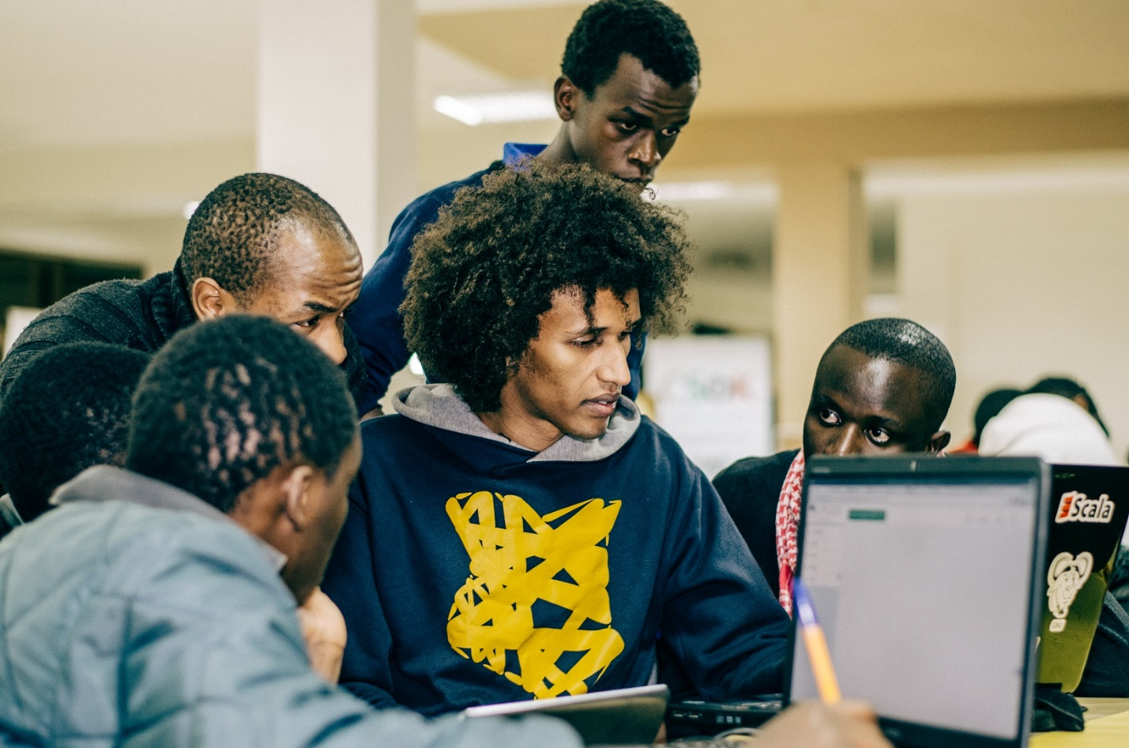 Afrikastalking providing training to all the groups working on SMS, VOICE and USSD platforms

Andela Kenya provided judges, they gave advice to the groups after presentation and promised to give the developers a deep training on languages they wish to learn. 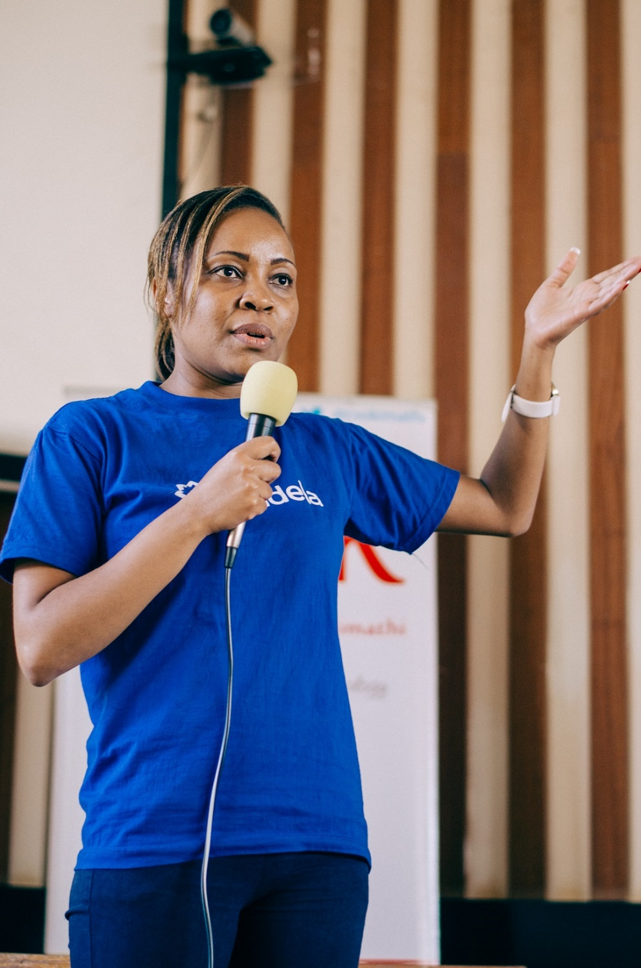

**Recommendations**

We should have many events of this nature to develop a depth of developers.

We should also include prizes to attract more participants at the event

**Winners of the event**

1. M-kuku
2. Auto home Afrika
3. Lost n found

We wish to incubate all these projects from the hackathon, in addition to projects that are already incubated at DeHUB.

1. Hakiki app
2. Nelion farm
3. Electruxx animation
4. Online notice board
5. Music app
6. Easy school